Promotion and Support Plan

Catacomb Descent

Game Development Masterclass - 22/23

Promotion and Support Plan Assignment

# 

**Table of contents**

**Game Pitch** 2

What is the game? 2

The team 4

**Future support and development** 4

Business Plan & Update Roadmap 4

**Funding** 8

Funding goals 8

Data Analysis 9

# **Game Pitch**

## What is the game?

Catacomb Descent is a 2D platformer built using Unity Engine. The game depicts a simple platformer with a childish art style. Its main pillars are represented by the fluidity of the gameplay and the depth that such simple mechanics can have. The simplicity of the design is built by the game’s simple mechanics and controls. The player does not have much to track, and the game is pretty straightforward, making it easy to understand and play for most people.

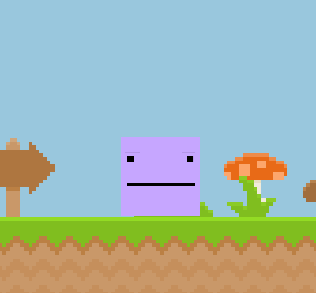

You play as an annoyed looking square ready to face the catacomb ahead and come out victorious! You move along the level as the game explains it is mechanics by text:

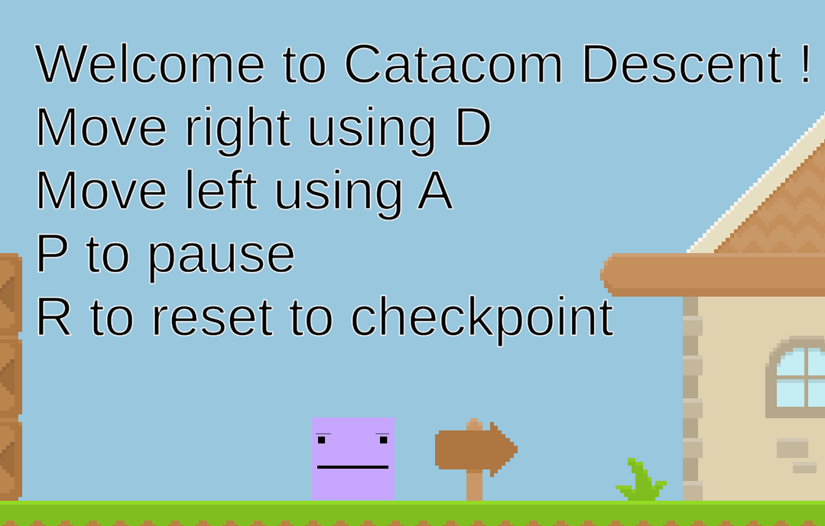

The game also offers the player enough checkpoints to not become frustratingly hard. The difficulty does ramp up as you go along but the design of the game dictates that it should not become in any way frustrating. 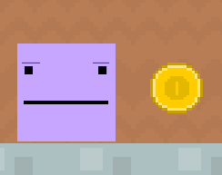

Shooter Enemy


The player faces many monsters throughout the dungeon but has a mean arsenal that will help them fend them off!

The challenge of the game consists of dodging enemy bullets and jumping over lava to reach the surface again. The hook might not be apparent, but it lies in how you use your abilities to overcome the challenges thrown at you in the most stylish way possible and with the least number of deaths!

## The team

The game is currently being worked on only by me, but as the goals get more ambitious as detailed below, so will the team get bigger!

# **Future support and development**

## Business Plan & Update Roadmap

The business plan is as follows:

The business plan is separated into two phases:

* Phase one: developing and refining the game.
* Phase two: introducing RNG (Loot box system) and a market of items for the players to sell / trade their items alongside a possible multiplayer feature. Also adding NFT’s as items and introducing said NFT’s into the marketplace.

Phase two is dependent on the funding. As more funding is available adding NFT’s will be easier and the integration smoother. It is a risk given the current situation with how prevalent frauds are in this space, but there seems to always be an interested public.

All updates correspond to the financial quarters of a year.

Little or no funding refers to: Not enough funding to start the hiring process for the project so the tasks will be done alone. If the interest in the project is not present the game will still be worked on as it is part passion project but might end abruptly after some time if motivation drops.

Moderate funding refers to: An adequate sum of money that will suffice for hiring at least an artist for the project and a game designer. This shows reasonable interest in the project and will motivate and help me to work on the project for a longer time, even more so if the public interest in the project starts to increase.

Generous funding refers to: A big sum of money, more than expected that will help achieve phase 1 of the project as soon as possible along with more people hired to work on the project. We would be looking at a team of fifteen people:

3 – Designers (Game)

3 – Programmers (Game)

2 – Designers (Monetization)

4 – Programmers (Monetization)

2 – Artists (Game)

1 – Artists (Advertising)

The first and most important update for the game will be to be ported onto mobile and browser to reach a broader audience. This is especially important and will be done regardless of funding.

If the project receives little or no funding:

1. Update 1: Expand the level.

* Expand the level to increase the playtime by adding interesting environments.
* Add another secret level with a reward at the end.

1. Update 2: Add a boss with mechanics.

* Design an engaging fight with mechanics that the player can learn as detailed in the original game GDD.

1. Update 3: Add more enemies.

* Add more enemies with unique attacks for the player to fend off.

1. Update 4: Work on presentation.

* Design a soundtrack.
* Add to the environments to make them feel more real.

The support plan will end at this time if no further funding is given to the project or if the interest of the project drops.

If the project receives moderate funding:

1. Update 1: Expand the level & add a boss with mechanics.

* Cram the two updates into one and with increasing quality as help will be available.

1. Update 2: Add more enemies and refine the art style.

* Adding more enemies and working on the art style alongside a designer will result in a final product of much higher quality.

1. Update 3: Further work on the presentation & polish.

* Add more enemies with unique attacks for the player to fend off.

1. Update 4: Adding monetization with Loot Boxes and Skins.

The support for the game is moderate and the work put in it will be even more so. The quality of the game would increase drastically.

If the project receives generous funding:

Hiring process begins as soon as possible.

1. Update 1: Expand the level & add a boss with mechanics & add more enemies & refine the art style.

* Have the team work as efficiently as possible on finishing phase 1 so we can get a reasonable number of elements from phase 2 into the game while other members of the team work on kickstarting phase 2.

1. Update 2: Further work on the presentation & polish along with the release of the monetization system and the market.

* Polishing the game as much as possible and releasing monetization should be feasible for this update alone with a big enough team.

1. Update 3: Multiplayer addition. Square off against your friends or random people in multiple platforming and combat minigames.

* Online multiplayer up to sixteen players!
* Update includes server setup and making sure no issues will arise during the launch of the update.

1. Update 4: Fully fledged NFT integration into the game along with the possibility of earning NFT’s while simply playing the game.

The support for the game is huge and the development team will make sure to deliver a high-quality product eventually even allowing players to make money from playing the game based on RNG while also encouraging the players through attractive microtransaction offers for in-game items.

Developing a Virtual Value Chain

The game’s files are structured in a way where they can be easily accessible even if they are not used in the final product. The data is stored in the editor and if not large enough will not be deleted. As long as the assets are reused and there is a sensible number of unused scripts that our future plans may require, the old unused data will not be deleted. A virtual value chain has already started developing throughout the process of making the game. Some assets have been reused to make a “hidden level” that has enlarged the game at a very low development cost.

Current development has kickstarted a value chain for the whole operation and future development will only benefit from it as it moves forward as it is a learning process with both failures and successes, but a focus will certainly be put on how we manage the failures and will strive to turn them into future successes.

As (Bhatt & Emdad, 2001) put it, the virtual value chain offers a number of distinct advantages that lie in a better customer – manufacturer alliance by the means of advertising while saving time and money with the efficiency of the virtual space. As games are digital products and advertising is as important if not even more so, advertising is emphasized and what lies as its foundation is the whole learning process of development as we try to be as community driven as we can allow.

As the game is a play to earn service coupled with the fact that it is a free game, the aim for the release of Phase 2 Monetization Updates date should be Q1 of the year more specifically January as people are less likely to spend money during that month on games after the holidays. (D’Argenio). Aiming for that period of the month might attract more players than any other busier period, although, it is, at the end of the day, a gamble but one with a minimal risk as the sales can be boosted by other means.

Promotion

Promotion for the project will come just as the roadmap for updates: in two phases:

Phase 1: promoting the game as is, a fun and engaging platformer that is free to play.

Phase 2: promoting skins, microtransactions and NFT’s if they will eventually be added into the game and advertise the game as a source of profit.

# **Funding**

## Funding goals

As stated above, the funding goals are separated into three groups:

* Little to no funding (Less than 50,000$)
* Moderate funding (50,000 – 100,000$)
* Generous funding (More than 500,000$)

Most of the money, if not all, will be used to hire people and pay them for a full year of development. The set goals are a reasonable asking for the scope of the project especially for the scope of Phase 2 which will be difficult to overcome.

There are risks involved, but there are a lot of money to be made in the Crypto space and it would be a missed opportunity not to try to develop a real game that is fun and enjoyable and promises people profit for simply playing.

Without generous funding Phase 2 of the project does not seem feasible. If the project is moderately funded additional funds can be made from ad revenue inside the mobile app.

## Data Analysis

As (Glassdoor, *Company salaries*) states, the salaries for the desired team roles are as follows:

* Programmer (Entry Level) – 66,668$/yr.
* Designer (Entry Level) – 35,327$/yr.
* Artist (Entry Level) – 42,174$/yr.

**Bibliography**

* Bhatt, G.D. and Emdad, A.F. (2001) *An analysis of the virtual value chain in Electronic Commerce*, *Logistics Information Management*. MCB UP Ltd. Available at: <https://www.emerald.com/insight/content/doi/10.1108/09576050110362465/full/html>.
* D'Argenio, A. (2020) A Breakdown of the Yearly Video Game Schedule. Available bit.ly/347Z8EM (Accessed: 8 September 2020).
* *Company salaries* (no date) *Glassdoor*. Available at: https://www.glassdoor.com/Salaries (Accessed: March 17, 2023).

## 